Welcome!
Congratulations on taking empowering steps to take control of your love life with the How to Choose a Man Program!
A history of problems in your dating and love life can cause emotional injuries and waste your time, leaving you confused and in the worst case scenario, doubting your own reality and future happiness.
In the How to Choose a Man Program you will learn how to find healthy people, meet more men, and know who they are very quickly upon meeting them, so you can find someone who makes you happy, get your needs met, and stop getting hurt.
Fill in the form below.

Personal Profile

1. Dating History: Please briefly list all the relationships you’ve been in, how they began and ended, how long they lasted and why they didn’t work. Each relationship should take maximum three lines.
Example:
2010 – 2015: Met___ in Starbucks, was in a relationship for two years, it ended by… because…
(Fill in here)

2. Dating Concerns and Challenges: What are your biggest concerns and challenges with your dating life right now?
(Fill in here)

2. Dating Goals: What are your relationship goals?
(Fill in here)

3. How do you currently meet men?
(Fill in here)

4. How many new men do you meet and talk to in an average month?
(Fill in here)
5a. What makes you happy? Simple things, (example: warm slippers, a clean kitchen, anything at all).
(Fill in here)

5b. What makes you happy? More complex things that are harder to bring about, (example: having a reliable work schedule, or cooking healthy meals, anything at all).
(Fill in here)

6a. What makes you unhappy? Simple things you can easily remove from your life (example: waiting until the last minute to pay the phone bill, anything at all).
(Fill in here)

6b. What makes you unhappy? More complex things that will take more time, planning and resources to remove from your life.
(Fill in here)

7. Needs: Happiness, a feeling of having control over your life and self-esteem come from getting your needs met. Looking at Maslow’s Hierarchy of Needs, which needs are you not getting met? List them below.
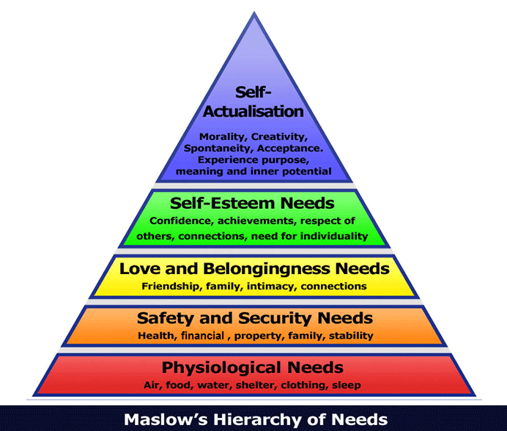

(Fill in here)

8. Road Map to You: Much as we are lovable and loving people, no one is easy to deal with ALL the time. Giving others a road map to how you work, what you need when you react a certain way or certain events happen, helps them understand you better and helps you get what you need, as well as not damaging relationships over the long-term. Please fill in below:
I can be difficult to handle when: (events happen, circumstances or anything else)
(Fill in here)
I am difficult to handle because (how do you behave?)
(Fill in here)
How do they handle me, what do they do? What do I need from my partner in those situations?
(Fill in here)

Dating Candidate Profile
What I want, Ideal:
What kind of person do you want to date / marry / have as a life partner? Write down everything,
every single thing you can think of under these headings, let your imagination fly, what will make
you truly happy?

1. Character: This is underlying traits, the person they are underneath. This includes their values. For example: loyal, etc.
(Fill in here)

2. Personality: Funny, dresses nicely, outgoing, likes to socialize, etc.
(Fill in here)

3. Interests: What do they like to do, what are they interested in?
(Fill in here)

4. Goals: What kind of goals do they have?
…

5. Lifestyle: Example: do you want to spend every Sunday watching football and
BBQing with them or would you rather be traveling? What kind of pattern does your
everyday life have?
(Fill in here)

6. Their emotional range while dealing with life: Many people get into patterns
and go through life in a certain range. What do you want your ideal partner’s emotional range or emotional approach to life to be?
(Fill in here)

7. Coping skills: What kind of coping skills must your ideal partner have to face life’s challenges? What kind of person do you want by your side?
(Fill in here)

What I Want, Realistic:
Fill in the top three most important things from your list above, in each category.

1. Character:
(Fill in here)

2. Personality:
(Fill in here)

3. Interests:
(Fill in here)

4. Goals:
(Fill in here)

5. Lifestyle:
(Fill in here)

6. Their emotional range while dealing with life:
(Fill in here)

7. Coping skills:
(Fill in here)

Dealbreakers:
My worst nightmare partner – things I absolutely cannot be around.

What traits can your partner absolutely not have? Let it fly here, write down every
single thing you can think of under these headings. Everything that has ever hurt you, annoyed
you, been a deal breaker in past relationships or would be, in your imagination.
What traits does your worst nightmare partner have? What kind of person do you not want to
date, marry, or have as a life partner? What would or has made you very unhappy?

1. Character: (worst nightmare, what do you really dislike as character traits or values? Example: unreliable etc.)
(Fill in here)

2. Personality: (worst nightmare, what do you really dislike?)
(Fill in here)

3. Interests: (worst nightmare, what would you really dislike your partner’s interests to be?)
(Fill in here)

4. Goals: (worst nightmare, what would you really dislike for them to have as goals?)
(Fill in here)

5. Lifestyle: (what kind of lifestyle would you really dislike?)
(Fill in here)

6. Their emotional range while dealing with life: (worst nightmare, what would you really dislike their emotional range to be?)
(Fill in here)

7. Coping skills: (worst nightmare if your partner had this way of reacting to life)
(Fill in here)

Realistic:
Top 3 Dealbreakers:
Fill in the top three dealbreakers from your list above, in each category.

1. Character:
(Fill in here)

2. Personality:
(Fill in here)

3. Interests:
(Fill in here)

4. Goals:
(Fill in here)

5. Lifestyle:
(Fill in here)

6. Their emotional range while dealing with life:
(Fill in here)

7. Coping skills:
(Fill in here)

Injuries

In what ways have you been injured by family?
☐ Criticism  ☐ Insults  ☐ Control  ☐ Blame  ☐ Putting you in danger  ☐ Physical violence  ☐ Name calling  ☐ Character assassination  ☐ Lack of praise  ☐ Overwhelming you with expectations / activities  ☐ Not respecting your boundaries, not having their own boundaries  ☐ Belittling you  ☐ Embarrassing you in public  ☐ Lack of physical affection | ☐ Shouting  ☐ Neglect  ☐ Abandonment  ☐ Gaslighting  ☐ Not supporting you  ☐ Verbal abuse  ☐ Labeling you  ☐ Comparing you to other people  ☐ Lack of respect  ☐ Not encouraging you  ☐ Preferential treatment of sibling/s  ☐ Intruding on your personal space  ☐ They treated you as the parent  ☐ Narcissism  ☐ It was always about what they needed / wanted | ☐ Not on your side  ☐ Not happy for your successes  ☐ Rude to you  ☐ Mocking / making fun of you  ☐ Fighting in your presence  ☐ Not acknowledging you exist  ☐ Ignoring you / silent treatment  ☐ Not prioritizing your needs  ☐ Over-protective / helicopter parent  ☐ Other (please describe)

In what ways have you been injured in relationships?
☐ Criticism  ☐ Insults  ☐ Control  ☐ Blame  ☐ Putting you in danger  ☐ Physical violence  ☐ Name calling  ☐ Character assassination  ☐ Lack of praise  ☐ Overwhelming you with expectations / activities  ☐ Promising the world, not following through  ☐ Lack of respect for your boundaries  ☐ Not having their own boundaries  ☐ Embarrassing you in public  ☐ Lack of physical affection | ☐ Shouting  ☐ Neglect  ☐ Abandonment  ☐ Gaslighting  ☐ Not supporting you  ☐ Verbal abuse  ☐ Labeling you  ☐ Comparing you to other people  ☐ Lack of respect  ☐ Not encouraging you  ☐ Cheating  ☐ Lying  ☐ Love bombing then abandonment  ☐ Pretending to be someone they’re not  ☐ Belittling you  ☐ Narcissism  ☐ It was always about them | ☐ Not on your side  ☐ Not happy for your successes  ☐ Rude to you  ☐ Mocking / making fun of you  ☐ Picking fights with you  ☐ Ignoring you / silent treatment  ☐ Not prioritizing your needs  ☐ Not giving you enough personal space / time  ☐ Intrusive  ☐ Using you  ☐ Expecting you to be their mother  ☐ Other (please describe)

In what ways have you felt supported by family?
(Fill in here)

In what ways have you felt supported in relationships?
(Fill in here)

- Fin -

